Sunday, March 7th, 2010
Hi
Not too much to write about. I note that in my letter of this time last week I commented on the pulsatile tinnitus that began in my right ear. It is still present but has changed to become a mixture of puffing and ringing sounds. It is not too loud and does not bother me. However, given that the experts said the Bell’s Palsy effects would have corrected themselves in a year, I expected the sound to be gone.
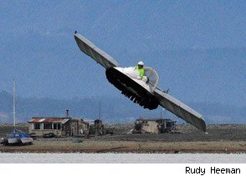
Saw on TV news – HK, BBC and Australian news – of a flying hovercraft invented by a guy in NZ. It must be the first craft that can travel on land, water and in the air. The wings are detachable. For a video of the craft in action, go to the following website:
http://www.asylum.co.uk/2010/03/02/flying-hovercraft-created-by-nz-inventor/
Very tough run yesterday. Very hot and humid – worse than last weekend. It took 3 h, 6 mins, which is nearly 1/2 hour slower than the best time. At Sek Kong, where I finished, the air temperature was 28⁰C. It is by far the hottest temperature for all the runs this season. There have been a few hotter days in past years but I think that with the heat plus humidity, the conditions for this run for the worst I have experienced. With the HK Marathon last weekend, the weather conditions affected times and all those interviewed commented on how difficult the conditions were. Today, temperatures are much cooler.
In the latest Time magazine, there is an article on nutrition in France’s schools and the suggestion that this might have something to do the lower levels of obesity and longer lives in France. Have a look at the following website (which is actually from the US rather than the Asian edition of the magazine; the text is the same though the pics are different):
http://www.time.com/time/world/article/0,8599,1967060,00.html
Re going to NZ. I have finally managed to get confirmed bookings with Air NZ. However, I would prefer to fly with Singapore Airlines and am on a waiting list; it is just one leg, from Christchurch to Singapore that is not confirmed.
That’s about it for now. Very short this week.

Cheers
PS: No-one seemed to notice that I put the wrong date on last week’s letter; I wrote February 29th, but there are only 28 days in February this year.

